WORDPRESS THEMES, WIDGETS & PLUGINS
Tasks
1.Install a new WordPress theme from the official WordPress theme repository and activate it on your test site. Take a screenshot of your homepage after activation.

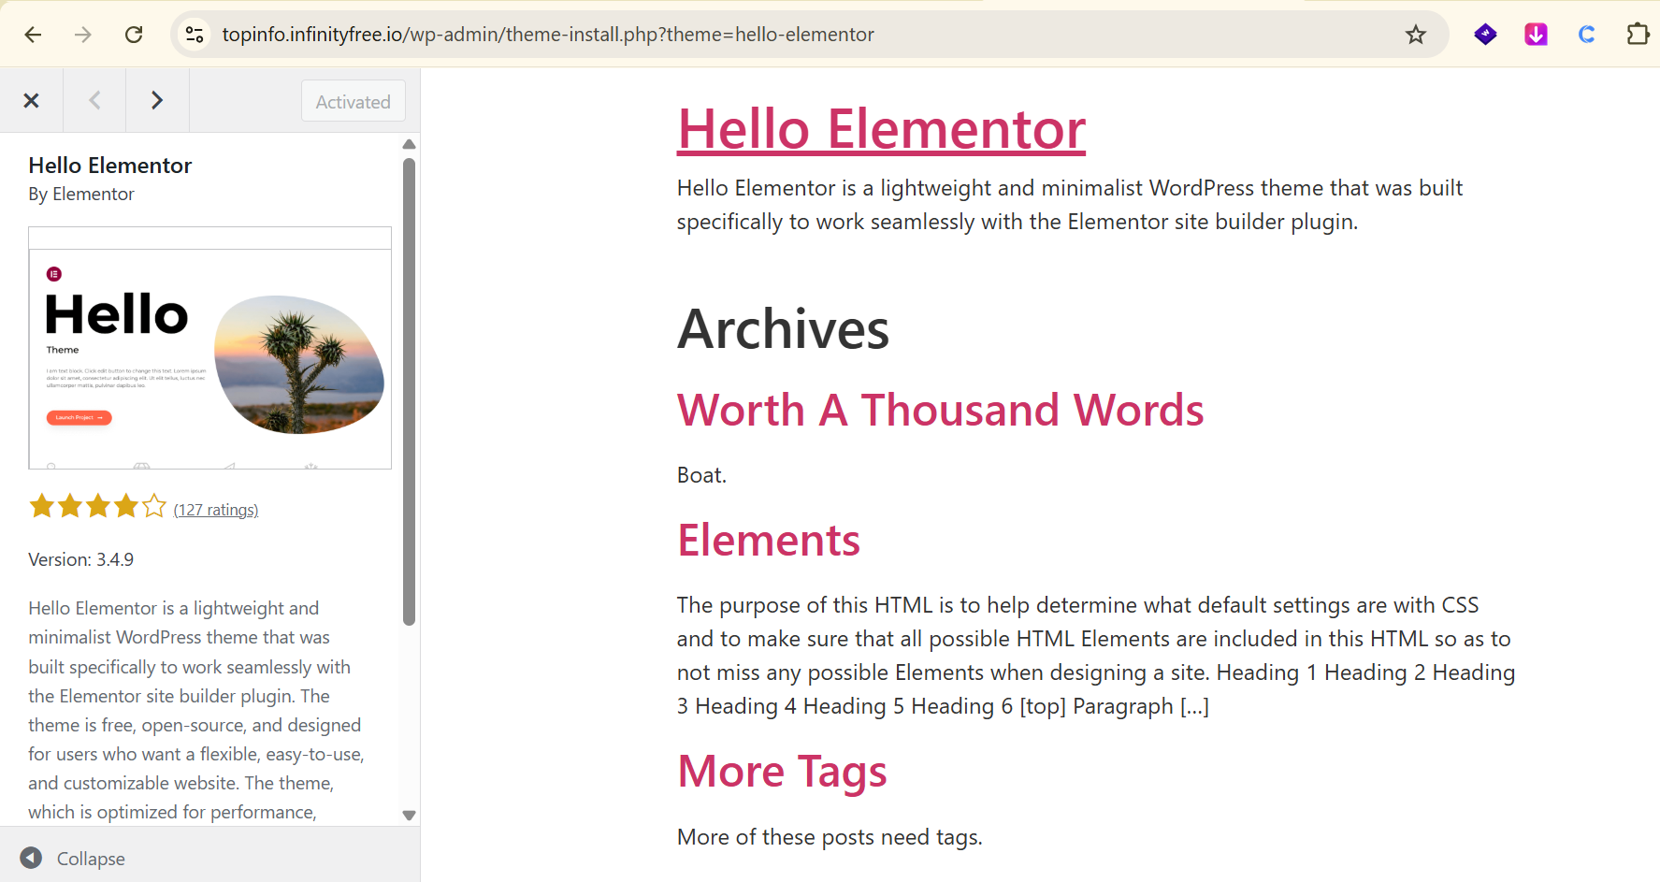

2.Customize your site’s sidebar using WordPress widgets — add a Search widget, Recent Posts widget, and an Instagram-like image gallery widget. Arrange them in your preferred order and preview the changes.
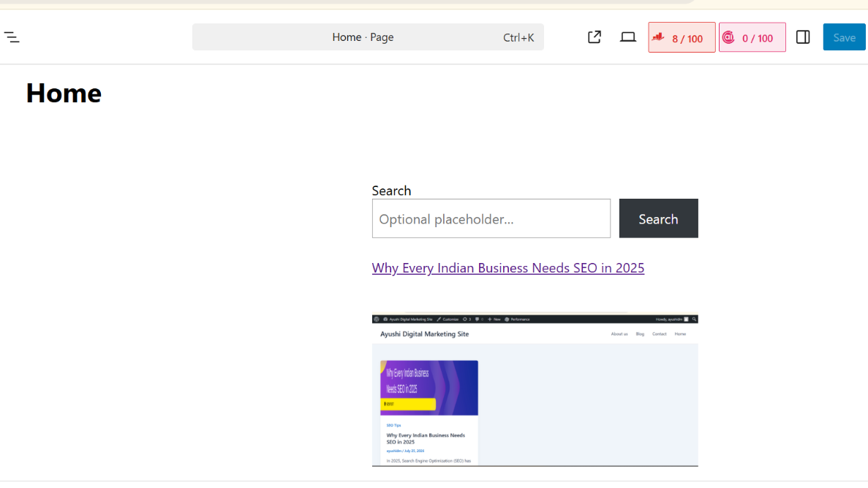
3.Install and activate a plugin that adds a contact form to your site (for example, Contact Form 7 or WPForms). Add a new contact form to your homepage and test submitting a message.

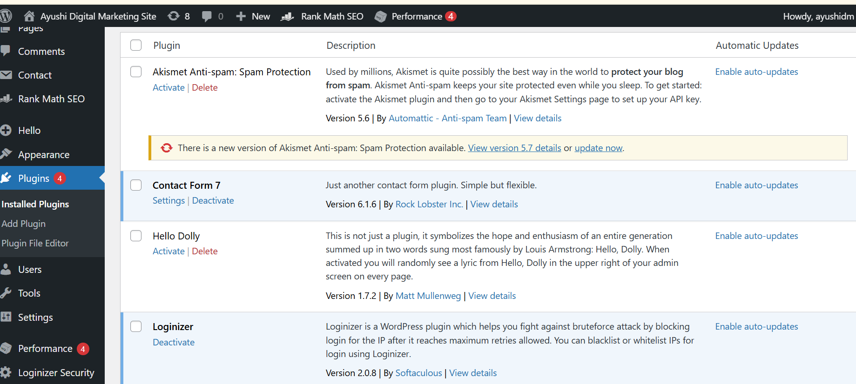

4.Find a free WordPress plugin that adds a social sharing bar to your posts (like for sharing to WhatsApp, Instagram, or Facebook). Install it, configure it to show on all blog posts, and verify that the sharing buttons appear correctly.
=> Answer : I installed a free social sharing plugin and configured it to display sharing buttons on all blog posts.
Sharing options :
-Whatsapp
-Facebook
-Instagram

5.Use ChatGPT or another AI tool to suggest three WordPress plugins that would make your site more interactive for users who love apps like Zomato, Flipkart, or Spotify. For each plugin, write one line about what feature it adds and why it’s relevant.<br><br><em><strong>Hint:</strong> Prompt example: 'Suggest 3 WordPress plugins to make my site more interactive, inspired by popular Indian apps.'</em>

Plugin | Feature | Why Useful
WPForms | Creates interactive forms and surveys | Helps users easily contact and interactive with the website.
Smash Balloon Social photo feed | Displays social media content on the website | Makes the website more engaging and interactive.
WooCommerce | Adds shopping and product feature | Useful for creating an interactive online shopping experience like Flipkart.

